Assignment 1:

(10 %)

(Last Date: 28th February 2025)

Create an Online Resume using React and Express.

OR

Create a Portfolio – I want you to do this, for yourself

(Check Page 2 and so on – Yes, I have to say this because sometimes we forget to scroll)

**Online Resume**

Objective:

Develop a basic React application using the react-bootstrap CLI integrated with an Express application. Your Express server will provide arrays of data for different sections of your resume, which your React application will fetch and display. Aim to design a clean and visually appealing online resume.

Guidelines:

1. React Application (Port 3000/ default port from Vite):

* Initialize your project using the Vite/CRA/ your frontend of choice.
* Fetch and loop through arrays of data from the Express server endpoints to display sections like education, experience, overview, etc.
* Make use of React components to achieve a responsive layout.
* Prioritize design elements such as padding, alignment, and layout.
* Maintain a professional look with consistent colors and typography.

1. Express Application (Port 8000):
   * Your server should have at least the following endpoints, each returning data:
     + /getEdu: Returns education details.
     + /getExp: Returns professional experience details.
     + /getOverview: Returns a brief about the individual.
     + Feel free to introduce more endpoints for additional sections like skills, certifications, etc.
   * Ensure CORS settings allow for communication from the React app running on port 3000.
2. Integration:
   * Your React application should make GET requests to the specified Express server endpoints and render the returned data. For example, to display education details, fetch data from the /getEdu endpoint.
3. Design Guidelines:
   * Padding: Ensure consistent padding around each section. Consider 15px for top and bottom padding and 10px for left and right.
   * Typography: Use clear font sizes. Headings should stand out (e.g., 24px), with subheadings and content being slightly smaller (e.g., 18px for subheadings and 16px for content).
   * Alignment: Left-align text for readability, but you can opt for center or right alignment for headings or other design elements. o Colors: Limit yourself to 3 primary colors to maintain cohesion. Ensure good contrast between text and background for readability.

Submission:

1. Upload both your React and Express projects as one repository or 1 sub directory inside your main GitHub directory for this class
   1. If you cannot, send the zip folder with both client and server-side code
   2. I will deduct marks if I must go through node modules
2. Provide a screenshot of the displayed online resume from your React application.

Grading:

1. Functionality (50%): All endpoints should be functional, and the React app should fetch and display the data without issues.
2. Design (30%): The appearance of the online resume is crucial. Proper implementation of padding, alignment, typography, and color schemes will be assessed.
3. Code Quality (20%): Your code should be structured, adequately commented, and devoid of unnecessary logs or debug statements. (remove them before your submissions)

**Reminder: Use fictitious data for all resume sections to ensure no personal or confidential information is shared.**

HELPER CODE SNIPPETS:

1. Fetching Data in React from an Endpoint:

To fetch data from your Express server within a React component, you can use the fetch function. Here's a simple example for fetching education details from the /getEdu endpoint:

JavaScript

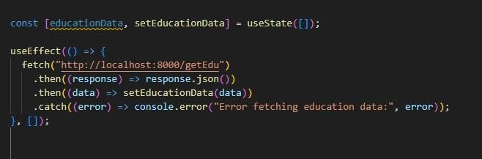

**Portfolio**

Just find something good on YouTube and make something for yourself. Its about having a place you can send others to show off why you are good at the job.

Make sure it looks good (clean, complete)

Make sure you can always add more to it in the future (modular structure)